Evaluator: Pontus Svensson

Reviewer: Leonardo Iwaya

‎‏DATE: 02/04/2024

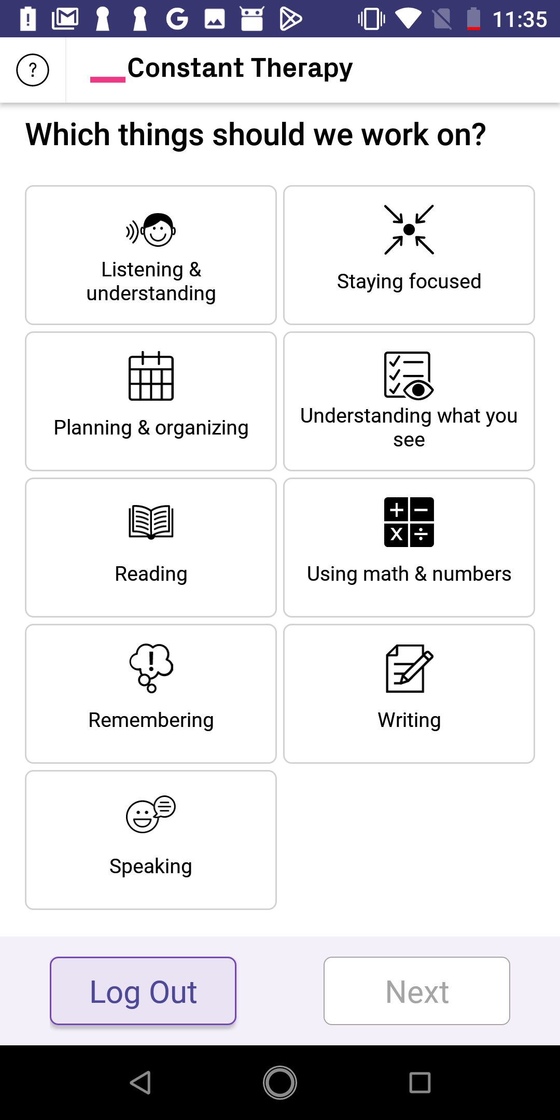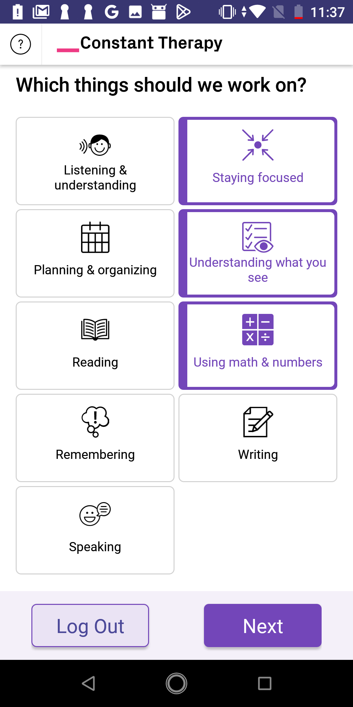

TASK: Setup for what should be worked on.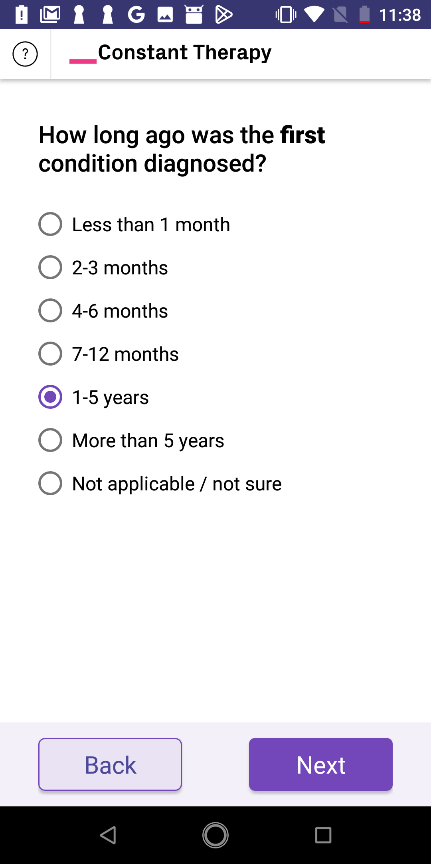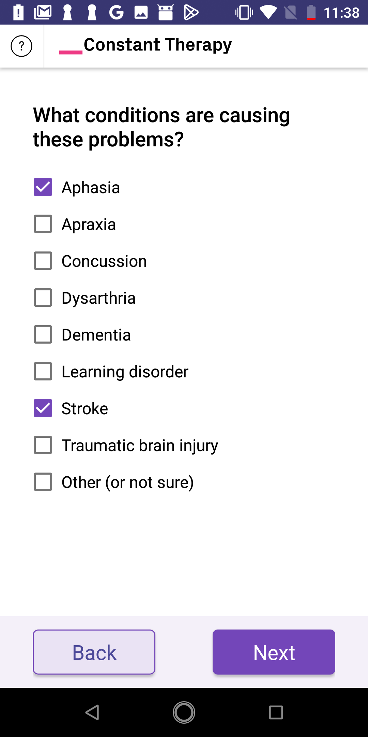

As we assess the screenshots to the right, showing the steps involved in selecting tasks to be addressed, it becomes apparent that numerous options are available for personalization. This emphasis on customization aligns well with heuristic seven, which emphasizes the importance of flexibility and efficiency of use.

1. The only violation that might be violated is **“visibility of system status,”** as some text might be too small for some users to read.

TASK: Therapy exercises for attention

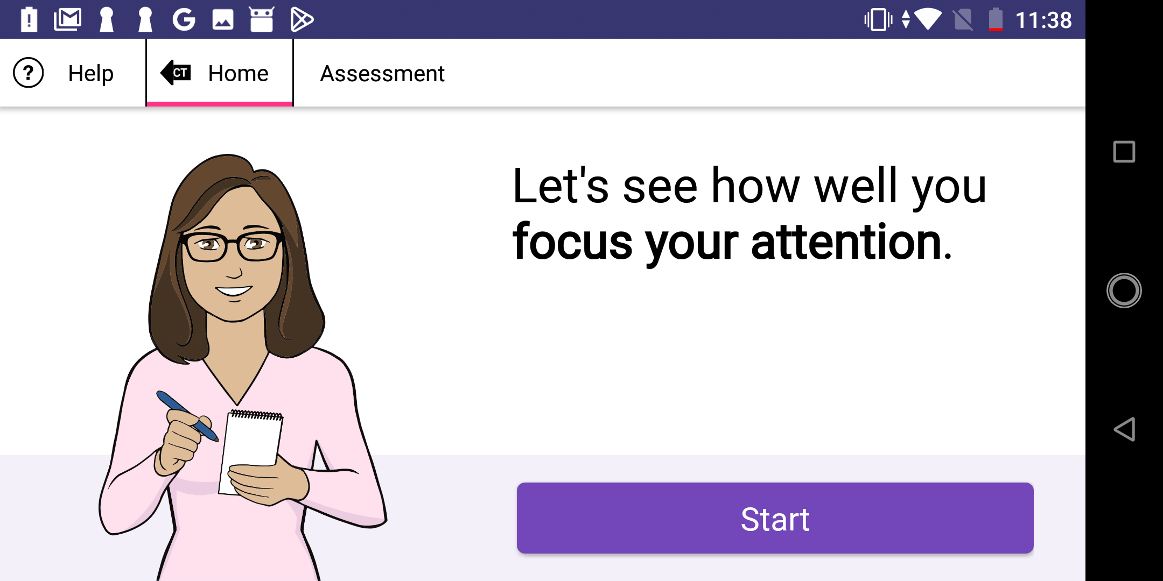

Down below and to the right, we can see the sequence of events while assessing one's attention.

2. When examining the alternating words feature shown in the third and fourth screenshots, it is evident that the text appears relatively small. Considering the abundance of unused space, enlarging the text could enhance readability, while still maintaining enough whitespace on the screen. Additionally, the text is pressable, resulting in a small interactive area. This could potentially make it challenging for individuals to select their desired word. As of now these potential problems contradict “**visibility of system status”**, as they prevent users from achieving their goal in an efficient way.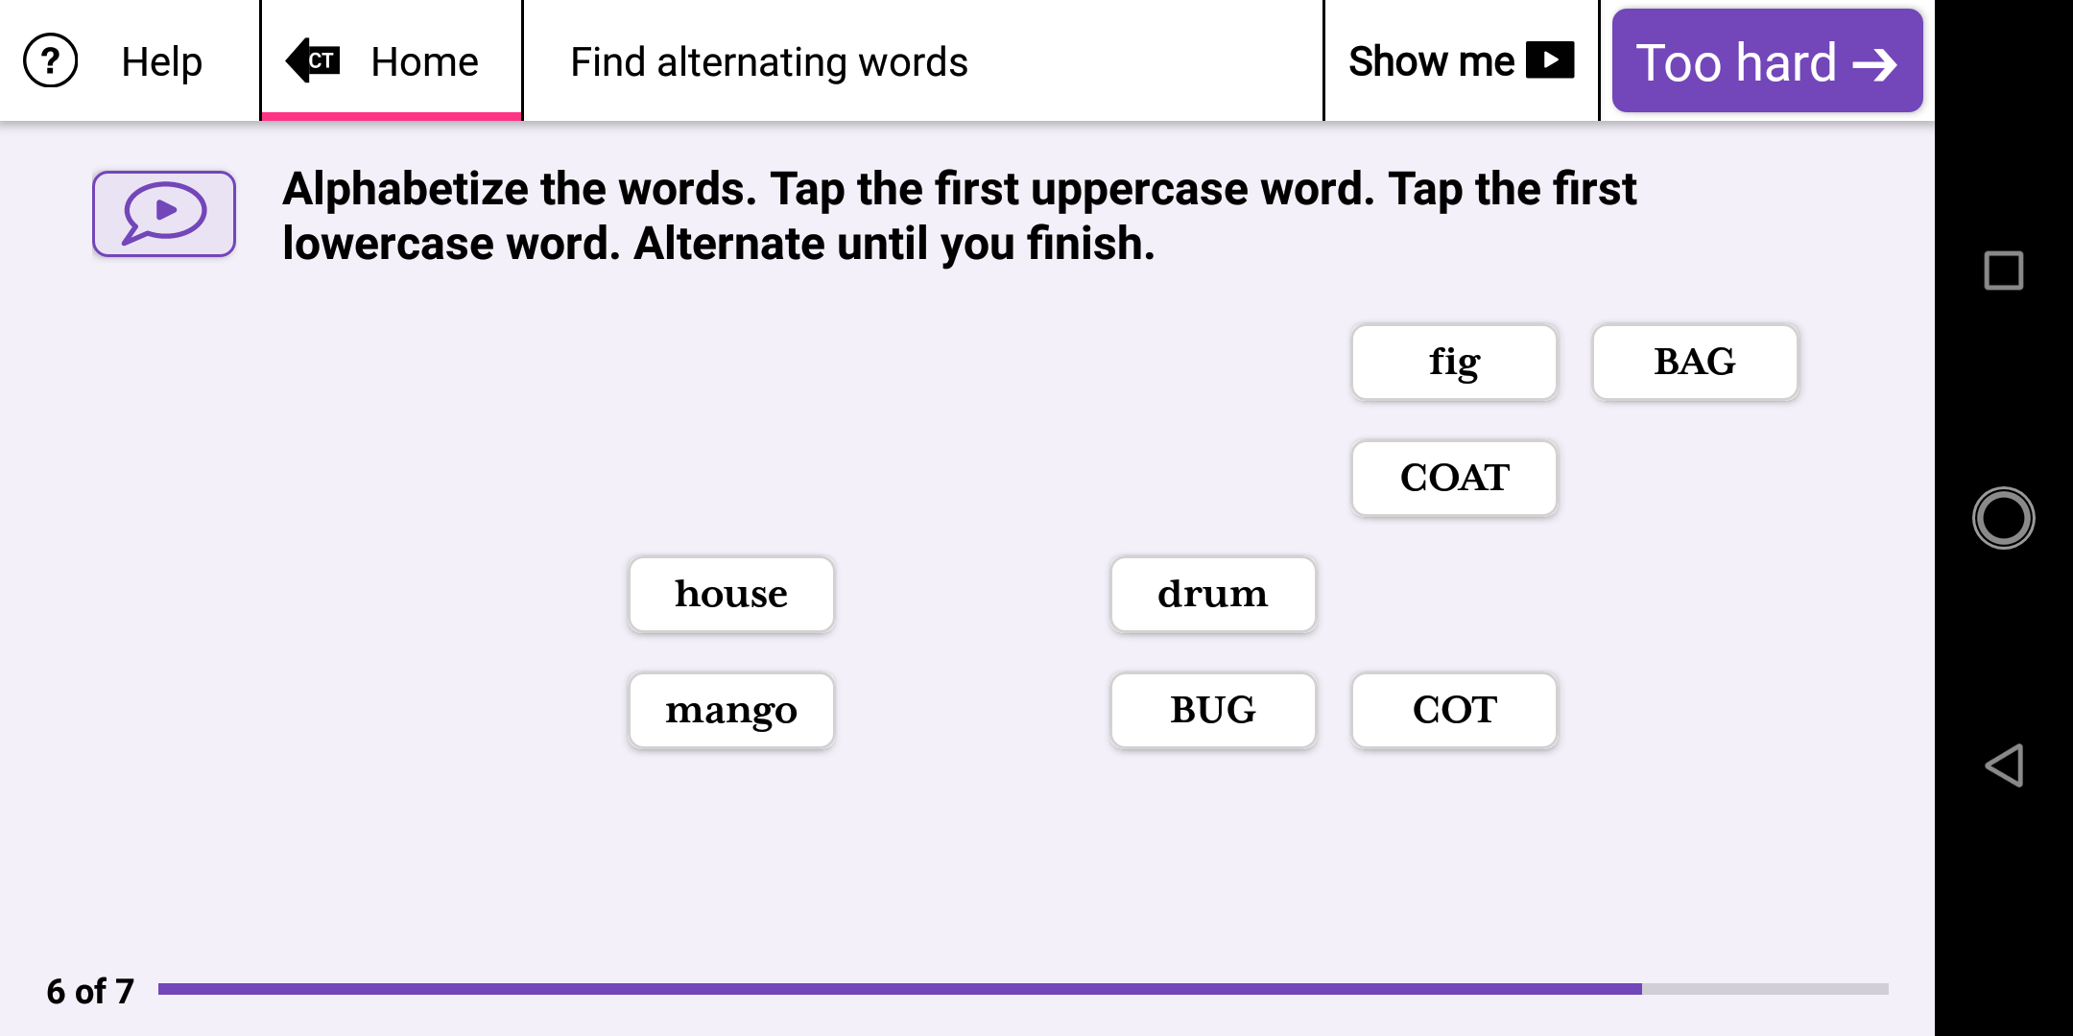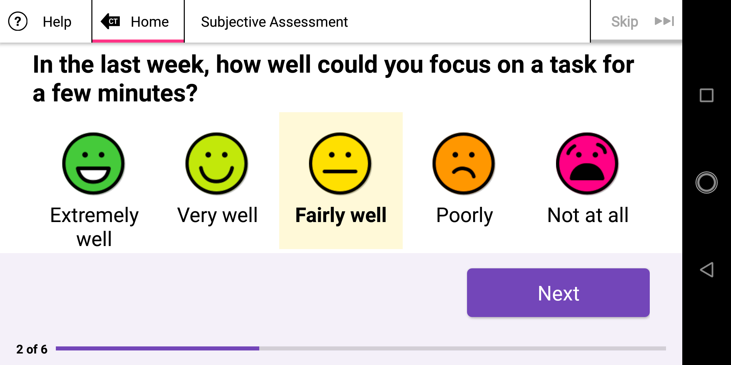

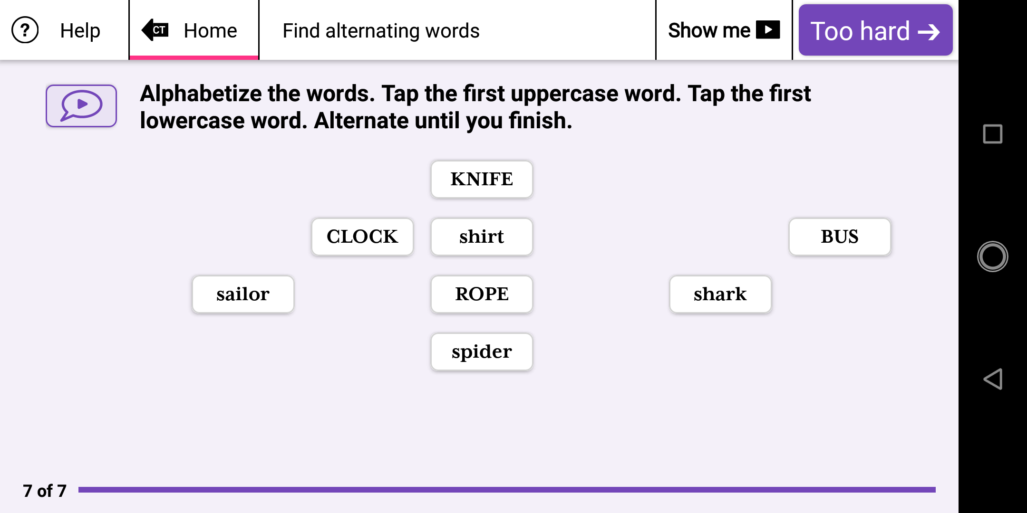

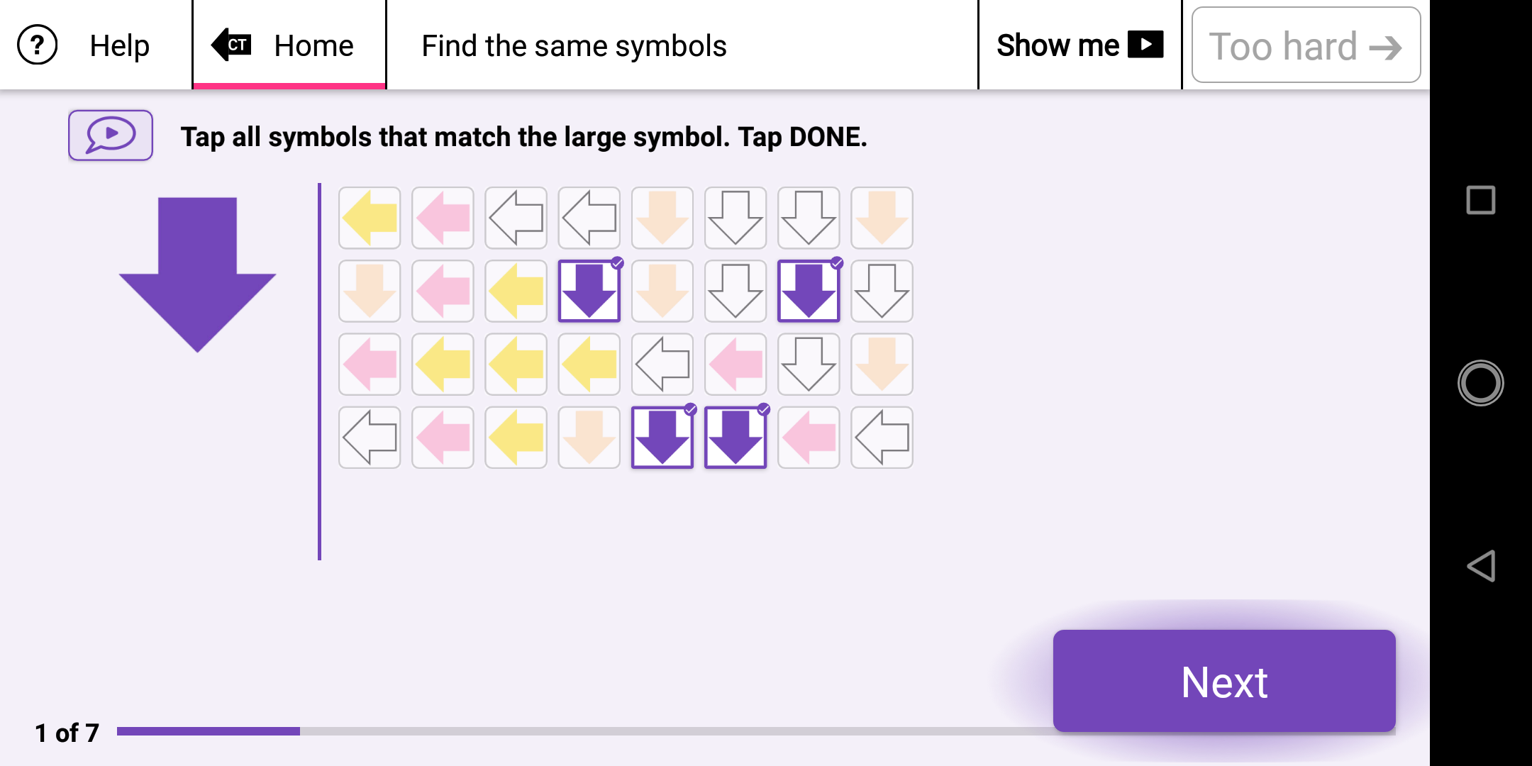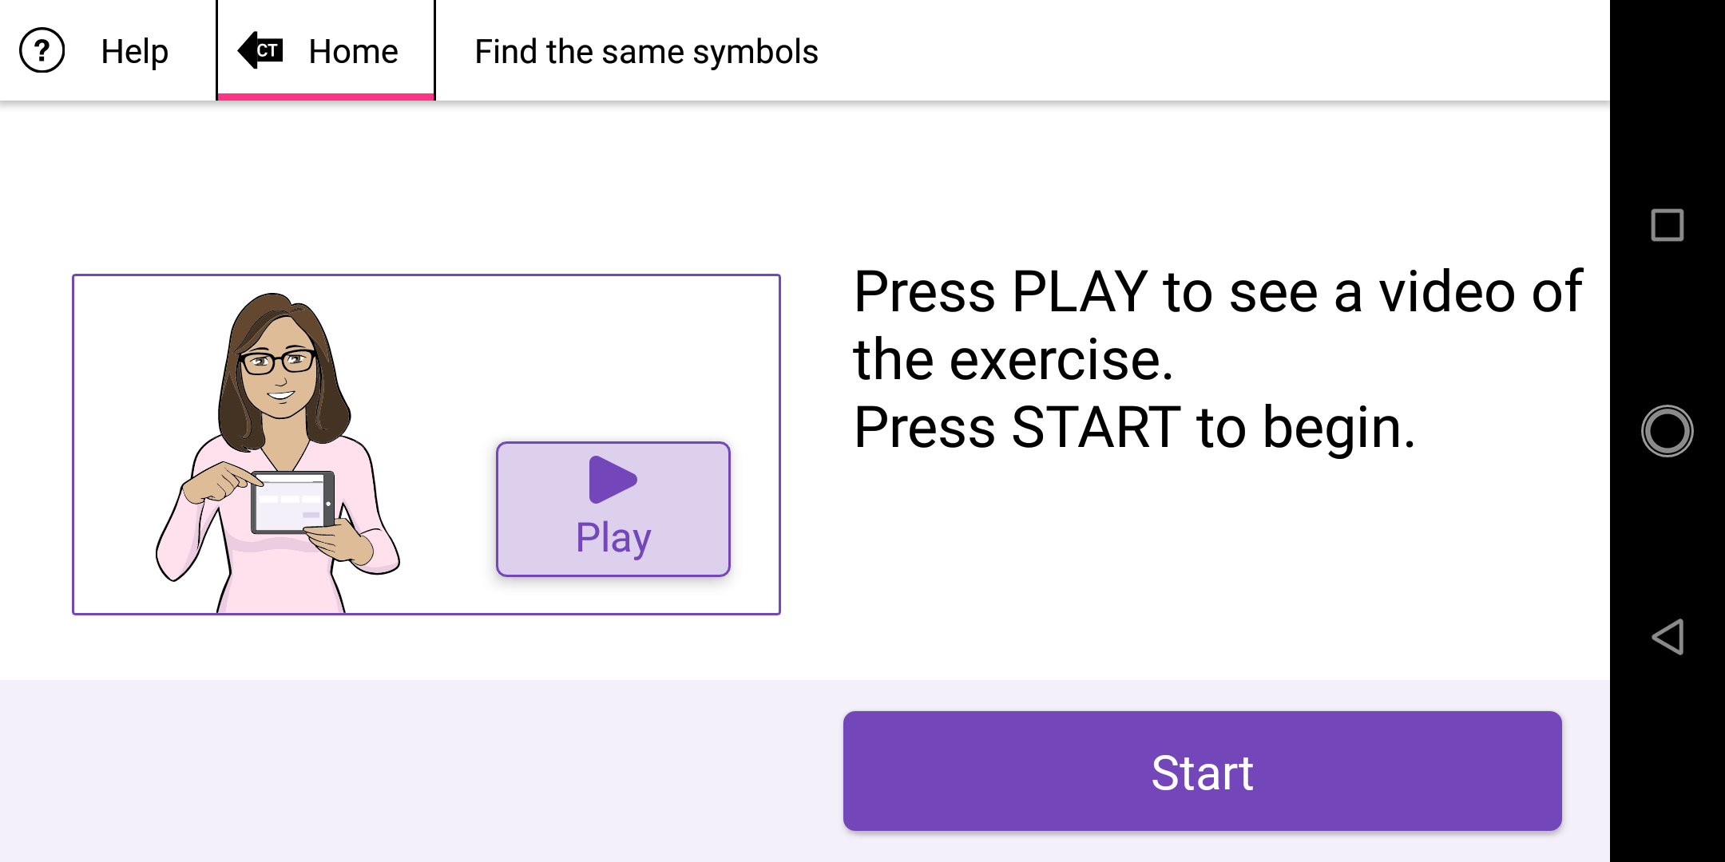

TASK: Therapy exercises for math problems

While looking at the screenshots below, which are part of assessing one's mathematical ability in different scenarios, we can see that the pictures can be hard to see. Still, here, we can tap the images to make them bigger, which solves the visibility problem.

The application provides clear error messages when the user enters an incorrect answer. These messages indicate the mistake made and present the correct answer, enabling the user to proceed to the next exercise.

